**EE-250L Electric Machinery Fundamentals**

**Name:**

Muhammad Asad

**Roll No & Section:**

2019-EE-383-A

1. **Stator Design on AutoCAD:**

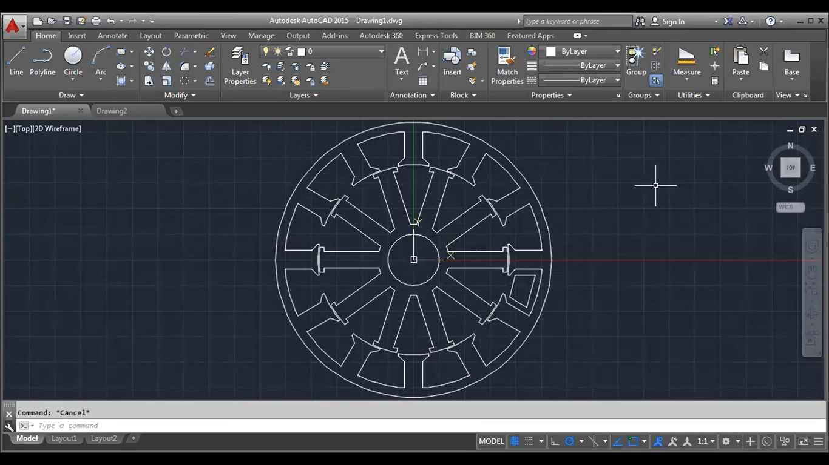

1. **Stator and Rotor Designated on ANSYS Maxwell:**

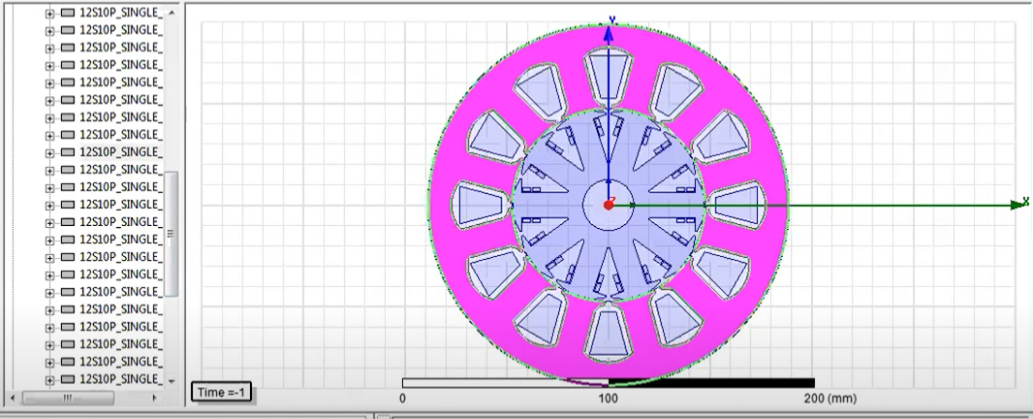

1. **120 conductors on Stator and 40 on each rotor , Calculated through (emoter.com/winding) Winding Calculator:**

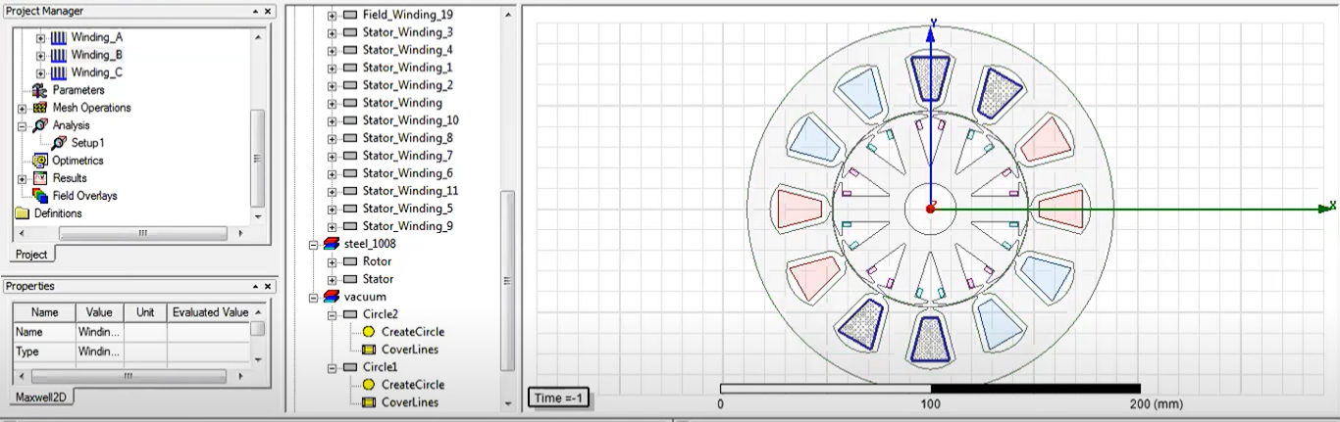

1. **Back EMF :**

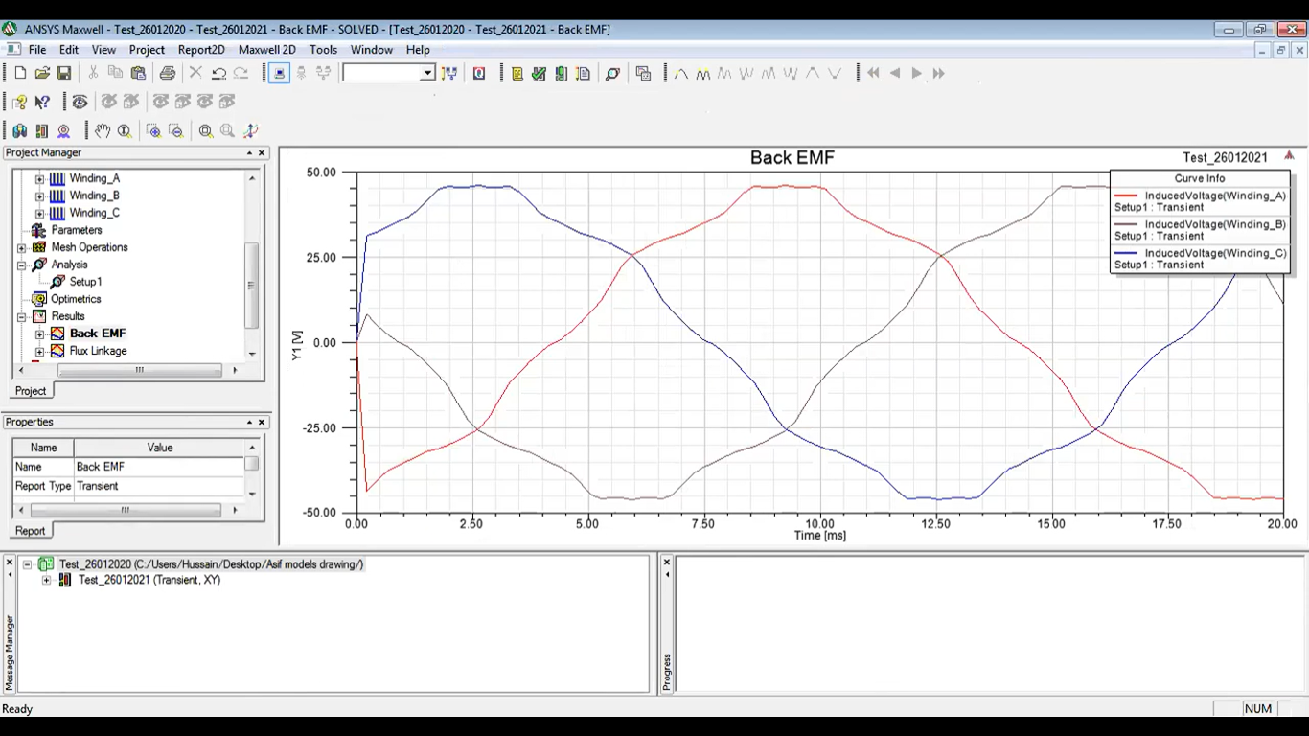

1. **Flux Linkage:**

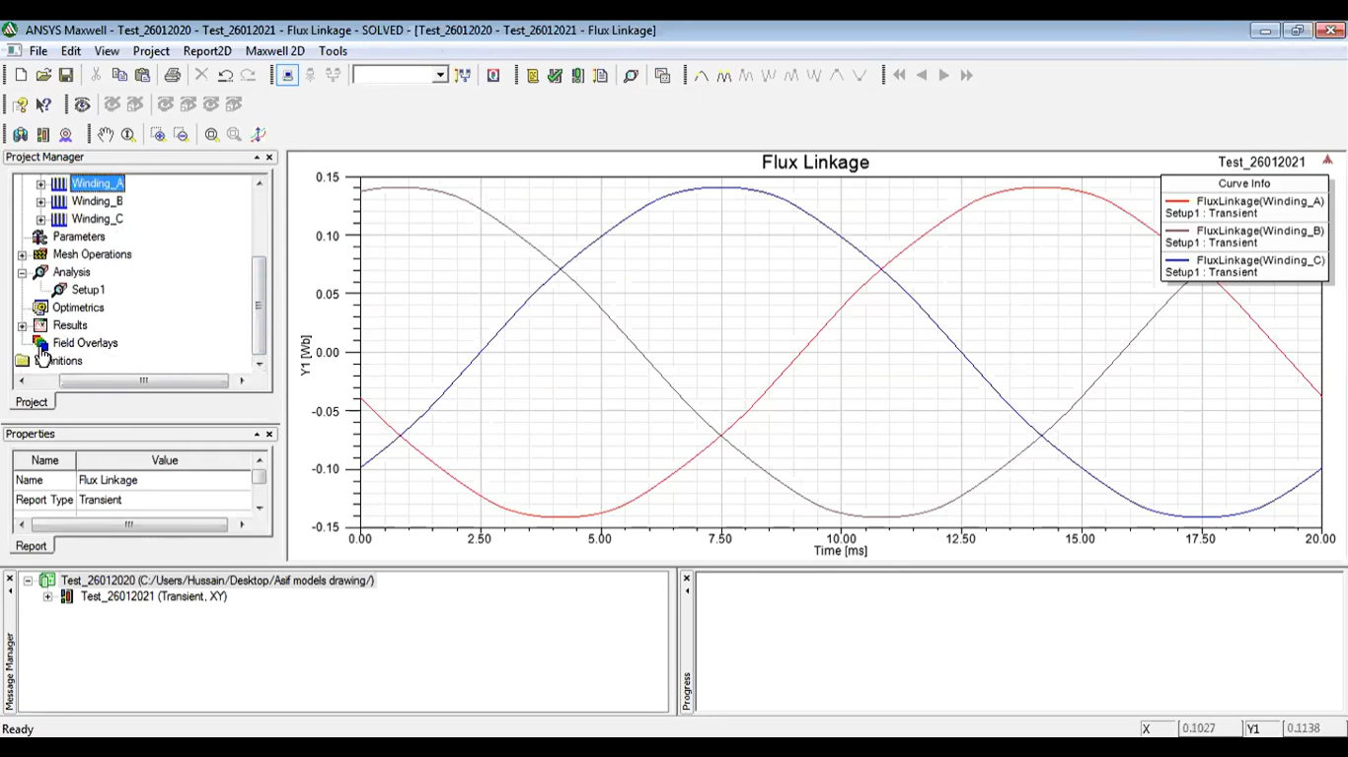

1. **Field Lines Density Model and Vector Field Model:**

